Victoria J. Coe
Children’s Book Author

BIO
Victoria J. Coe is the author of FENWAY AND HATTIE (GP Putnam’s Sons/Penguin Young Readers) - the Global Read Aloud for Early Readers, Amazon Teacher’s Pick, and a “One School, One Book” favorite. She’s also written 3 FENWAY AND HATTIE sequels, a 4-book illustrated chapter book series called MAKE WAY FOR FENWAY!, and EZRA & THE MOUSE: THE SEARCH FOR LAFAYETTE, a stand-alone middle grade novel. She loves to conduct fun POV workshops and Q&A sessions with K-5 students both in person & online. A founding member of the Sweet 16s, Victoria lives with her husband in Boston and Duxbury, Massachusetts.
Web site: victoriajcoe.com
Twitter & Instagram: @victoriajcoe
Email: victoriajcoe.com/contact
Rights inquiries: Marietta B. Zacker of Gallt & Zacker Literary Agency
Media inquiries: Sierra Pregosin at spregosin@penguinrandomhouse.com

BOOKS
FENWAY AND HATTIE (Putnam 2016) Ages 8-12
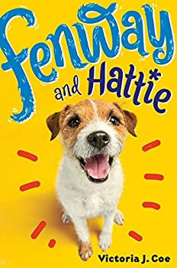
Paperback ISBN 9780147514905 192 pages
Ebook ISBN 9780698182363
Audio ISBN 9780593501245 read by Tara Sands, 225 minutes
This lovable series introduces a little dog with a GIANT personality!
Fenway is an excitable and endlessly energetic Jack Russell terrier. He lives in the city with Food Lady, Fetch Man, and—of course—his beloved short human and best-friend-in-the-world, Hattie.
But when his family moves to the suburbs, Fenway faces a world of changes. He’s pretty pleased with the huge Dog Park behind his new home, but he’s not so happy about the Evil Squirrels that taunt him from the trees, the super-slippery Wicked Floor in the Eating Room, and the changes that have come over Hattie lately. Rather than playing with Fenway, she seems more interested in her new short human friend and learning to play baseball. His friends in the Dog Park next door say Hattie is outgrowing him, but that can’t be right. And he’s going to prove it!
Get a dog’s-eye view of the world in this heartwarming, enthusiastic “tail” about two best friends.
“A fun, fresh frolic that animal-loving kids are sure to enjoy.” – Publishers Weekly
Global Read Aloud, Amazon Teachers’ Pick, One School, One Book “Sweet Spot” Selection, Texas Reads One Book, Mississippi Reads One Book, #OneBookConnects, Wisconsin State Reading Association “Just One More Page” Selection

FENWAY AND HATTIE AND THE EVIL BUNNY GANG (Putnam 2017) Ages 8-12
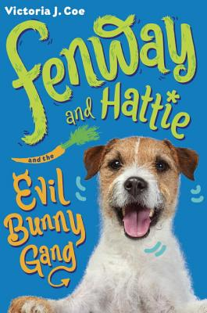
Paperback ISBN 9781101996348 208 pages
Ebook ISBN 9781101996355
Audio ISBN 9780593501269 read by Tara Sands, 255 minutes
The lovable little dog with a GIANT personality is back—battling something that may be worse than squirrels!
Life is pretty much a bag of treats when you’re an endlessly energetic Jack Russell Terrier. For Fenway, days are filled with important things like defending the Dog Park from wicked squirrels, snuggling with Hattie, and catching up on the neighborhood gossip with the next-door dogs Goldie and Patches. But that all changes the day a fiendish new intruder enters Fenway’s turf: he’s fluffy, he twitches evilly, and he smells worse than squirrels…
He’s a bunny. An evil bunny. And Fenway can’t fathom why, but Hattie ADORES him. Goldie and Patches warn him that short humans are fickle: sometimes they love a new pet more than an old one. Fenway can’t believe his own Hattie would choose another pet over him. But taking matters into his own paws just makes everything worse. Is his heart big enough to accept that Hattie can love another pet too–and is he tough enough to take on an entire gang of evil bunnies?

FENWAY AND HATTIE UP TO NEW TRICKS (Putnam 2018) Ages 8-12
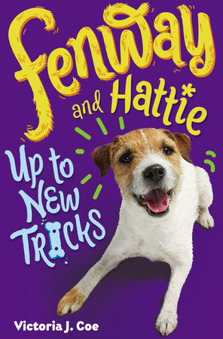
Paperback ISBN 9781524737856 208 pages
Ebook ISBN 9781524737849
Fenway's dog's-eye-view of the world is as enthusiastic as ever, but his favorite short human is not acting the way he expects--and he doesn't like it one bit!
Fenway's life is pretty great, except for the strange stripey chipmunks that have suddenly appeared in the Dog Park behind his house. He's determined to catch them, but one of their hiding places contains some stinging insects. Ouch! Fenway thinks he can take care of this injury himself, but his humans don't let him. They take him to the Place of Fear and then Hattie doesn't even help him take off the Cone of Doom!
Fenway never would have expected Hattie to do these things to him. Doesn't she love him anymore? But even though his family is acting weird, Fenway is determined do whatever it takes to make them all happy again.

FENWAY AND HATTIE IN THE WILD (Putnam 2019) Ages 8-12
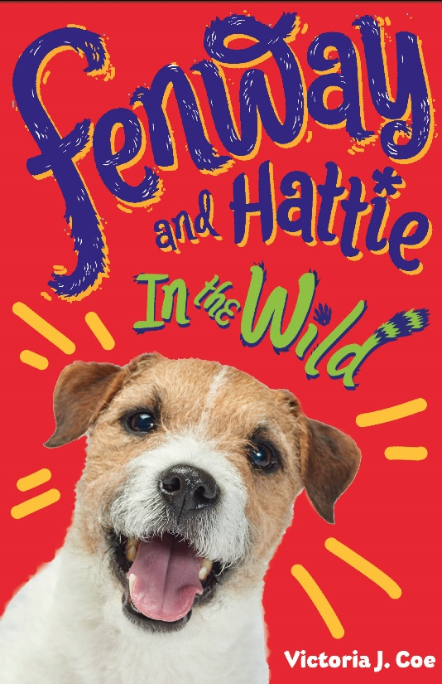
Paperback ISBN 9781984812520 192 pages
Ebook ISBN 9781984812513
Fenway gets a taste of the wild when he goes on a back-to-school camping trip in the fourth book in this adorable middle-grade series, now in paperback!
When Hattie starts using a word Fenway hasn't heard in a long, long time - "skool" - some other things change as well. The family fills the Food Box with yummy hot dogs and loads it in the car! Fenway is thrilled that he gets to go along wherever they are going, and is even more excited when they arrive in the wilderness with tons of new scents to investigate, dogs and humans to meet, and lots of meat cooking over fires.
Hattie seems excited about it all, too, and happy her friend Angel also came, but when more families arrive with lots of new kids, she starts to smell nervous. Especially when one certain kid that all the others seem to follow everywhere starts bossing everyone around. Fenway can sympathize, because a tiny dog is doing the same thing to all the other dogs. Fitting in can be a tough business, but luckily both Fenway and Hattie come around to realizing that being true to themselves is much more important.
FENWAY Y HATTIE (Puffin 2019) Ages 8-12
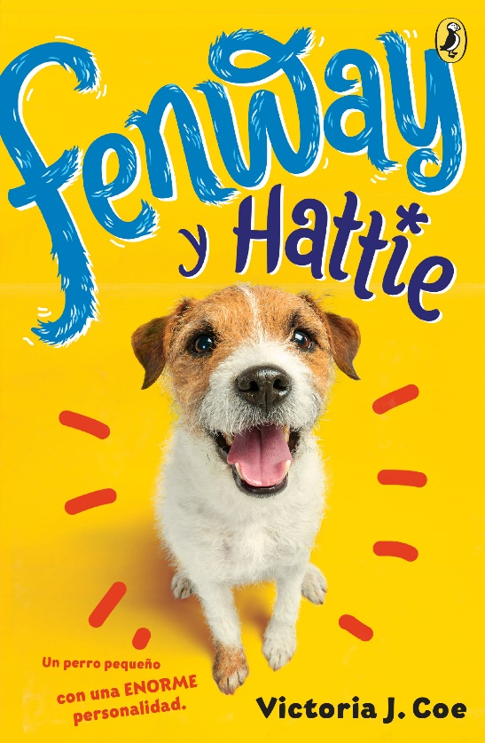
Paperback ISBN 9780593110058 176 pages
Ebook ISBN 9780593110133
The 2017 Global Read Aloud and One School, One Book favorite about a little dog with a big personality is now in Spanish!
¡Observa el mundo a través de los ojos de un perro en esta entretenida historia sobre dos amigos inseparables!
Fenway y Hattie, su adorada pequeña humana, hacen una pareja perfecta. A ella le gusta ir al Parque de Perros, saltar la cuerda, jugar a la pelota y disfrutar de comida deliciosa tanto como a él. Pero cuando se mudan de la ciudad a un barrio en las afueras, las cosas cambian radicalmente. Hattie se pasa todo el tiempo en una casa en lo alto de un árbol, que pareciera ser la casa de unas ardillas, y juega a la pelota sin él. Abatido y confundido, Fenway emprende una misión: va a recuperar a su Hattie, y nada ni nadie lo va a detener, ni el Malvado Piso, ni la aterradora Reja, ¡ni siquiera una ardilla gigantesca!

EZRA & THE MOUSE: THE SEARCH FOR LAFAYETTE (Duxbury Rural & Historical Society 2021) Ages 8-12
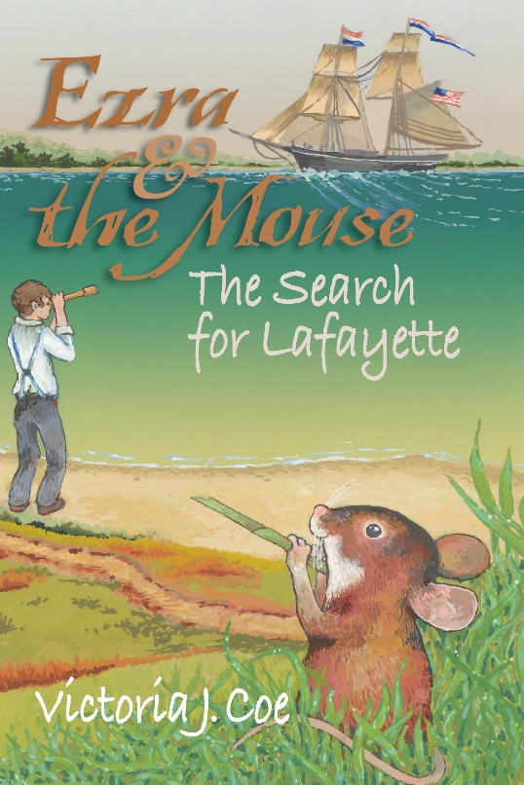
Paperback ISBN 9780941859134 197 pages
Cover illustration by Walter Swartz
Set in Duxbury, Massachusetts in 1822, this fast-paced historical adventure that will have readers rooting for two unlikely heroes – Ezra Weston IV, the 12-year-old grandson of the shipping magnate known as King Caesar, and a mouse named Bertie that Ezra and his cousin Elizabeth Bradford rescue (or “capture”) at the shipyard. Told in dual points of view, inspired by actual events, and written by Duxbury native and popular children’s author Victoria J. Coe, readers of all ages will delight in seeing Duxbury’s shipbuilding past come to life while discovering a surprising, yet little known episode about the Marquis de Lafayette.
All proceeds of the sale of this book are being donated by the author and illustrator to support the mission of the Duxbury Rural & Historical Society. Info: Duxburyhistory.org.

FENWAY AND THE BONE THIEVES (MAKE WAY FOR FENWAY! #1) (Putnam 2022) Ages 5-8
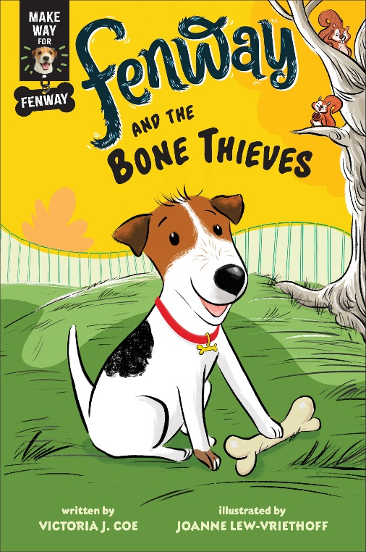
Hardcover ISBN 9780593406915 96 pages
Paperback ISBN 9780593406922 96 pages
Ebook ISBN 9780593406939
Audio ISBN 9780593507636 read by Tara Sands, 42 minutes
Illustrated by Joanne Lew-Vriethoff
The little dog with a GIANT personality from Fenway and Hattie is starring in his own chapter book series!
There’s nothing better than a brand-new bone!
And nothing worse than sneaky squirrels trying to steal it! But Fenway is smarter than those squirrels, and he finds the perfect place to hide his bone.
The only problem is the hiding place might be too hard for Fenway to find, too!
With an easy reading level and lively illustrations, emerging readers will be eager to get their paws on the Make Way for Fenway! chapter books.

FENWAY AND THE FRISBEE TRICK (MAKE WAY FOR FENWAY! #2) (Putnam 2022) Ages 5-8
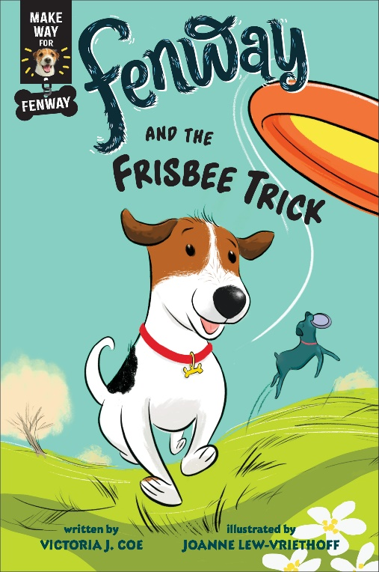
Hardcover ISBN 9780593406946 96 pages
Paperback ISBN 9780593406953
Ebook ISBN 9780593406960
Audio ISBN 9780593507834 read by Tara Sands, 40 minutes
Illustrated by Joanne Lew-Vriethoff
The little dog with a GIANT personality from Fenway and Hattie is starring in his own chapter book series!
Fenway is ready to learn a new trick!
When Fenway sees a dog leap into the air and catch a Frisbee, he wants to do it, too. But catching a Frisbee is harder than it looks.
Good thing Fenway is willing to keep trying, and he impresses everyone with a special trick of his own!
With an easy reading level and lively illustrations, emerging readers will be eager to get their paws on the Make Way for Fenway! chapter books.
Amazon Editors’ Pick, “Best Books for ages 6-8”

